Lab 02 Tasks:

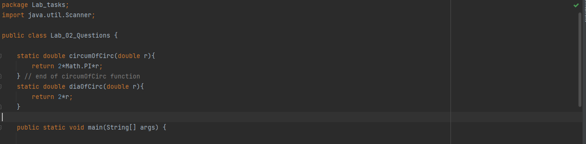

// Question 01: Declaring, finding sum and average of 5 floating point numbers  
System.*out*.println("Question 01: Declaring, finding sum and average of 5 floating point numbers");  
float f1 = 45.7f, f2 = 78.6f, f3 = 4.56f, f4 = 78.00f, f5 = 12.5f;  
float sum = f1+f2+f3+f4+f5;  
System.*out*.println("Sum of "+f1+"+"+f2+"+"+f3+"+"+f4+"+"+f5+" is "+sum);  
  
// Question 2: Finding diameter and circumference of three circle with radius values  
System.*out*.println("Question 2: Finding diameter and circumference of three circle with radius values");  
Scanner sc = new Scanner(System.*in*);  
for(int i=1; i<=3; i++)  
{  
 System.*out*.print("Enter value of radius for circle " + i + ": ");  
 double rad = sc.nextDouble();  
 System.*out*.println("Circumference of circle "+i+" is "+*circumOfCirc*(rad));  
 System.*out*.println("Diameter of circle "+i+" is "+*diaOfCirc*(rad));  
} // end of for loop  
  
// Question 03  
System.*out*.println("Question 03");  
int num = 5843;  
int result = num / 5843;  
System.*out*.println("Rs.5000: "+result);  
int num2 = num % 5000;  
int result2 = num2 / 1000;  
System.*out*.println("Rs.1000: "+result2);  
int result3 = num2 / 500;  
System.*out*.println("Rs.500: "+result3);  
int num3 = num2 % 500;  
int result4 = num3 / 100;  
System.*out*.println("Rs.100: "+result4);  
int num4 = num3 % 100;  
int result5 = num4 / 50;  
System.*out*.println("Rs.50: "+result5);  
int result6 = num4 / 10;  
System.*out*.println("Rs.10: "+result6);  
int num5 = num4 % 10;  
int result7 = num5 / 5;  
System.*out*.println("Rs.5: "+result7);  
int result8 = num5 / 1;  
System.*out*.println("Rs.1: "+result8);

***Output:***

